Self-referral for Counselling Portal Guidance

Version Control | Changes Made | Author
Version 1 – April 2023 |  | HR/OD

Introduction

Employee self-referral is for counselling only, any other referral e.g.physiotherapy, must be discussed and submitted by your manager.

Your referral will be treated in confidence unless it is considered that you may be of risk of harm to yourself or others.

The Occupational Health Service operates during normal office hours. If you are completing this referral outside of this time and are in crisis you should contact your GP’s surgery in the first instance. A list of other agencies who may be of help can be found on the website below:-

https://legacy.cumberland.gov.uk/employeeinformation/wellbeing/default.asp

Please note counselling can be provided to employees as an interim measure of support whilst the employee seeks longer term treatment and support through their GP. Once your referral has been triaged then you will be referred to a counsellor initially for up to four sessions. The counsellor will provide feedback only on whether the sessions have been beneficial and whether you attended. Details discussed during the counselling sessions will not be disclosed.

Getting Started
1 | https://GenohsisPortal.cumbria.gov.uk/Portal | You should access the system using the link
2 | 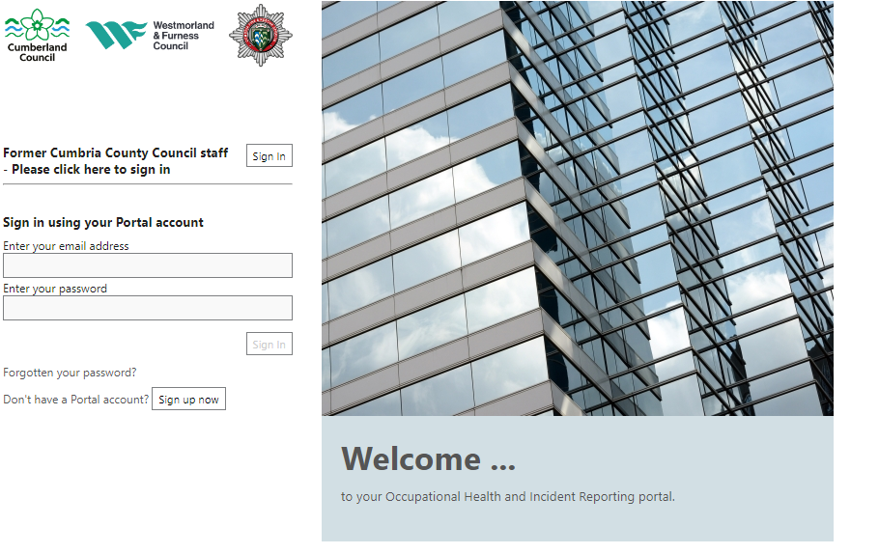 | You will need to “Sign up” to the system by clicking on the button shown  .
3 |  | Complete the boxes  The company reference is M500FAB8  The password should contain – upper and lower case, numbers and symbols.  If this is the first time you log in you will receive a verification email from the system. You will need to go to that email and following the instructions.  Enter your personal details  Click on next
4 |  | Enter your personal details  Click on next  Enter your contact details  You do not need to complete the employment details.  Please click on Save Changes
5 |  | If at any time the expected pick list seems to move or not be in the correct place then you please change your zoom to between 100 and 125%. This should correct the problem.  Quick Guides – you can exit the quick guides by click on the “Exit quick guides” button
6 | 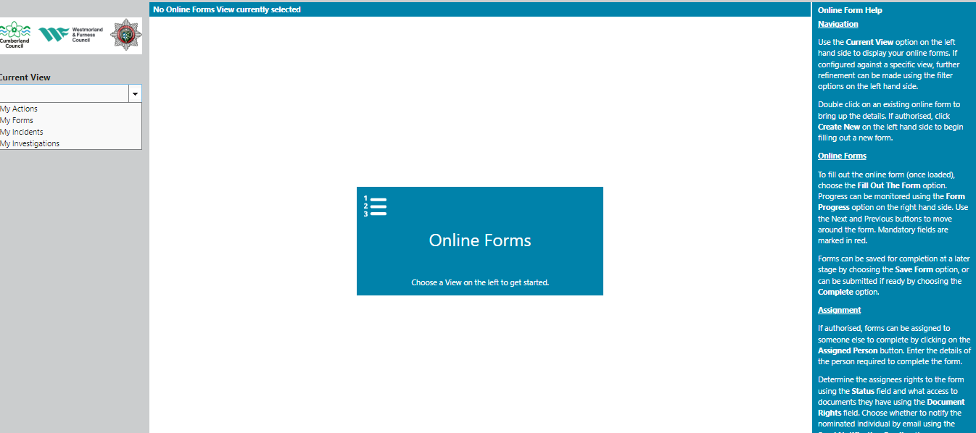 | Create a new medical referral  To create a new medical referral form click on the drop down arrow.  Choose “My Forms”  The other items in this list are concerned with the Safety side of the system and can be ignored.
.Creating a Self-referral for Counselling Questionnaire
7 | 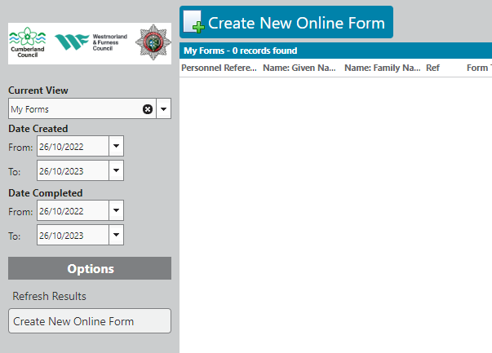 | To create a new form  Click on “Create New Online form”
8 | 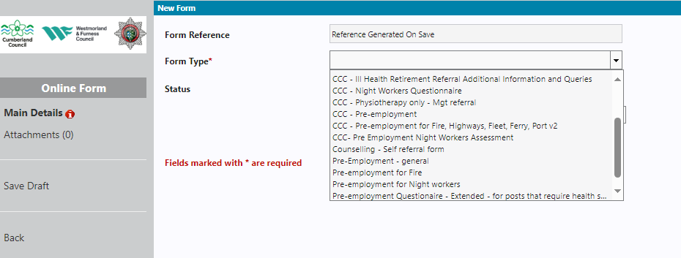 | Click on the drop down list in form type. Choose the  Counselling – Self Referral form.  Click on continue and complete the rest of the questionnaire.  Please ensure that you have provided a suitable telephone contact as the Counsellor will contact you directly following referral.  You can “Save Draft” at any point.
9 | 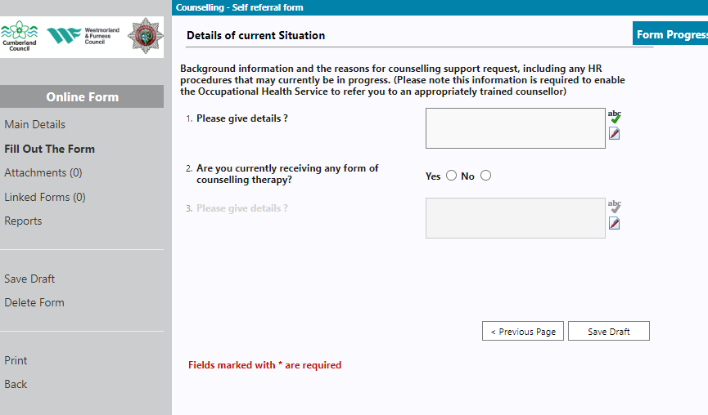 | Once you have finished please ensure you click on the submit button.
Your form will then be sent to the Occupational Health Service and they will triage the form. They may contact you if they need any further details.

If you have any difficulties please call the Occupational Health Service on 01768 812556.

