LEAVE ENTITLEMENT CALCULATOR – GUIDANCE FOR USE

Version Control | Changes Made | Author
Version 1 – April 2023 |  | HR/OD

The Leave Entitlement Calculator is a one page spreadsheet which is designed to assist with leave calculations, it requires minimal input. This guidance provides detail of how the calculator’s cells can be used to work out simple leave calculations, and others that require a bit more thought.

If you haven’t used the calculator before it’s worth reading all of the guidance to find out how it all works and what can be achieved. If you only need a quick reminder - hover over a relevant heading to go straight to a relevant section you need.

- Mandatory cells:
  - Hours per week
  - Number of weeks worked
  - Date of birth
  - Continuous service date

- Optional cells
  - Name and position title
  - Leaving date – if applicable
  - New starter date – if applicable

- Dealing with changes and non straightforward leave calculations
- New starters with continuous service
- Starting and leaving in the same year
- Changing the number of working hours part way through a leave year:
Increase in hours
Decrease in hours

- The Leave Record template
- A completed example

Once you have input the required information, the calculator provides:

- annual leave entitlement for the year you are calculating (birthday to next birthday)
- bank holiday entitlement for the leave period you are calculating
- where applicable, annual leave and bank holiday entitlements for leavers
- where applicable, annual leave and bank holiday entitlements for new starters
- where applicable, annual leave and bank holiday entitlements for employees with variable hours

THE LEAVE CALCULATOR

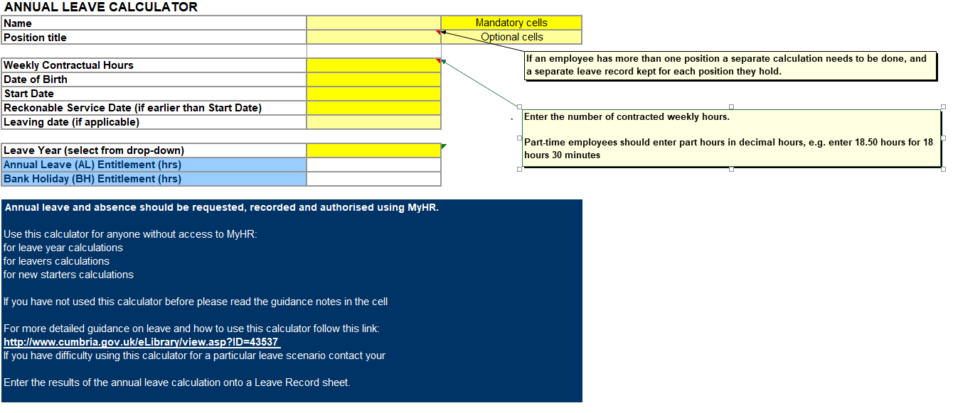
Mandatory cells

The mandatory information needed to make the calculator work correctly is input into the cells shaded bright yellow.

Optional cells | Optional data can be input into the cells marked pale yellow:

- Leaving date cell – where someone leaves the council during their current leave year and prior to their next birthday, complete the mandatory cells and enter the day after their last day of service. Entering the date following the leave date allows the calculator to include the leaving date itself in the calculation.
Name and position title are also optional cells in the Leave Calculator. All other cells are protected and cannot be amended. There is no requirement for you to save an electronic copy for each individual as once produced you will enter the calculated entitlement results onto an individual Leave Record. If required, calculations can be redone at any time.

Dealing with changes and not straight-forward leave entitlement scenarios
Changes may occur part way through a leave year that result in the need to make a variation to an individual’s leave entitlement. In these cases, the Leave Record will need to be adjusted accordingly to take into account the leave entitlement variation calculated, which may be up or down depending on a person’s circumstances.

Employees who change their working hours part way through a leave year

If an employee changes their number of working hours part way through a leave year you can still work out their entitlement by entering the number of hours worked in a particular period. You will need to enter two different sets of information in the calculator fields

The same principle can be used where an employee’s hours temporarily change for a set period of time within the leave year. By using the fields of the calculator, you can work out the additional amount of leave entitlement accrued for a set period of time.

If you have difficulty working out a particular scenario using the calculator please contact a member of the Human Resources team for assistance.

LEAVE RECORD

Employee name: |  |  |  | Post:
Directorate: |  |  |  | Line Manager:
Birthday: |  |  |  | Date of Continuous Service:
Hours per week: |  |  |  | Working weeks per year:
Pattern of work:  (number of hours per day): | M | T | W |  | T | F |  | S | S

Notes:
- The leave year runs from the birthday to the day prior to the next birthday.
- Annual increases in leave entitlement will commence from an employee’s start date and increase up to the maximum number of days (30).
- This leave record should be completed in ink by the employee named above. Any request for leave must be agreed and authorised by the Line Manager named above prior to any leave being taken (including flexi-time).
- Leave entitlements to be calculated on a pro rata basis for part time and / or part year (TT) staff. Part-time workers leave must be recorded and taken in hours, not days.
- Use the leave calculator available on Intouch to assist with entitlement calculations.

Full Year (Full Time Equivalent) Annual Leave Entitlements, with effect from 01/10/11: |  |  |  |  |  |  | Full Year (Full Time Equivalent) Bank / Public Holiday Entitlements, with effect from 01/10/11 (to be allocated on date they fall)
 | In Year 1 | In Year 2 | In Year 3 | In Year 4 | In Year 5
Days: | 24 | 25 | 27 | 29 | 30 |  | 8 days
Hours: | 178 | 185 | 200 | 215 | 222 |  | 59.2 hours

 |  | Annual leave entitlement  *(days/hours):  AL | Bank holiday entitlement  *(days/hours):  BH
Leave carried forward from previous year:
(maximum of 5 working days, to be taken within 6 months)
Leave year period from  (last birthday): | Leave year period to  (next birthday):
Additional annual leave purchased:
(must be taken within relevant leave year)
Total for current leave year:
(round hourly entitlements up to nearest half hour)
Line Manager certification:
(signature)

Date From | Date To  (inclusive) | No of Days /Hours taken | Leave Type  (AL/BH/Flexi) | Days / Hours remaining |  | Authorised (Line Manager) | Noted in Dept/ Directorate
 |  |  |  | AL | BH
Carried forward from page 1
This Leave Record is also available electronically:

Leave Record – Full time/Days (electronic version)
Leave Record – Part time/Hours (electronic version)

Note: Leave requests by the employee and authorisation by a line manager can be done electronically by email between the people concerned.

LEAVE RECORD – A completed example

Employee name: | Grace Williamson |  |  | Post: |  |  | Business Support Team Leader
Directorate: | Adult and Local Services |  |  | Line Manager: |  |  | Caroline Reardon
Birthday: | 31 December |  |  | Date of Continuous Service: |  |  | 16 August 2009
Hours per week: | 30 |  |  | Working weeks per year: |  |  | 52.14
Pattern of work:  (number of hours per day): | M | T | W |  | T | F |  | S | S
 | 7.5 | 7.5 | 7.5 |  | 7.5

Important notes:
- The leave year runs from the birthday to the day prior to the next birthday (inclusive).
- Annual increases in leave entitlement will commence from an employee’s start date and increase up to the maximum number of days (30).
Full Year (Full Time Equivalent) Annual Leave Entitlements, with effect from 01/10/11: |  |  |  |  |  |  | Full Year (Full Time Equivalent) Bank / Public Holiday Entitlements, with effect from 01/10/11 (to be allocated on date they fall)
 | In Year 1 | In Year 2 | In Year 3 | In Year 4 | In Year 5
Days: | 24 | 25 | 27 | 29 | 30 |  | 8 days
Hours: | 178 | 185 | 200 | 215 | 222 |  | 59.2 hours
- This leave record should be completed by the employee named above. Any request for leave must be agreed and authorised by the Line Manager named above prior to any leave being taken (including flexi-time).
- Leave entitlements to be calculated on a pro rata basis for part time and / or part year (term time) staff. Part-time workers leave must be recorded and taken in hours, not days.
- Use the leave calculator available on Intouch to assist with calculations.

 |  | Annual leave entitlement  (hours):  AL | Bank holiday entitlement  (hours)  BH
Leave carried forward from previous year:  (maximum of 5 working days, to be taken within 6 months) |  | 30
Leave year period from  (last birthday): | Leave period to  (next birthday/leave date): | 176.5 | 48  (6hrs per BH (8))
31/12/12 | 31/12/13
Additional annual leave purchased:
(must be taken within relevant leave year)
Total for current leave year:  (round hourly entitlements up to nearest half hour) |  | 216.5 | 48
Line Manager certification:
(signature)

Date From | Date To  (inclusive) | No of Days /Hours taken | Leave Type  (AL/BH/Flexi) | Days / Hours remaining |  | Authorised (Line Manager) | Noted in Dept/ Directorate
 |  |  |  | AL | BH
1/1/13 | 3/1/13 | 24 | 6BH/18AL | 198.5 | 42
11/2/13 | 14/2/13 | 30 | 7.5 FL/22.5AL | 176 | 42
1/4/13 | 4/4/13 | 30 | 12BH/18AL | 158 | 30
6/5/13 | 7/5/13 | 15 | 6BH/9AL | 149 | 24
27/5/13 | 6/6/13 | 60 | 6BH/54AL | 95 | 18
29/7/13 | 29/7/13 | 7.5 | FL | 95 | 18
5/8/13 | 8/8/13 | 30 | AL | 65 | 18
26/8/13 | 29/8/13 | 30 | 6BH/2.5FL/21.5AL | 43.5 | 12
28/10/13 | 29/10/13 | 15 | 2.5FL/12.5AL | 31 | 12
Carried forward from page 1 |  |  |  | 31 | 12
4/12/13 | 5/12/13 | 15 | 7.5FL/4.5AL | 26.5 | 12
23/12/13 | 26/12/13 | 30 | 12BH/18AL | 8.5 to c/f | 0

