CFRS
Policy

Flexible Duty System & Leave for Station and Group Managers -
GREY BOOK

Contents

Introduction
Policy
Duty System
Annual Leave & Public Holiday Entitlement
Public Holiday Working
Resilience
Pay
Appendices

‘North and South’ operational cover zones
Introduction

  - Station and Group Managers within Cumbria Fire & Rescue Service will be conditioned to the ‘Flexible Duty System’ as defined by the NJC Scheme of Conditions of Service Sixth Edition 2004 (updated 2009) Section 4 – Conditions of Service Framework, Part A hours of duty and duty systems. This document sets out locally agreed amendments to the above duty system.

Policy

2.1 The Policy sets out the guidance in the following areas:

• Duty System
• Annual Leave & Public Holiday Entitlement
• Public Holiday Working
• Resilience
• Payment

Duty System

3.1 The hours of duty of full-time employees on this system shall be as set out below. The hours of duty of part-time employees shall be pro-rata. Employees on this system shall perform two types of duty:

  - Managerial Duty; which is rostered for operational command, managerial supervision and/or specialist duties appropriate to the employee’s post. This is known as ‘positive hours’

  - Standby/Call Out duty; which is rostered so that the employee is available on call for the urgent performance of managerial duty.

3.2 Group and Station Managers on this duty system will be allocated a base in one of the following geographical areas and work on the following four week rota groups:

Rota  Position | Barrow/Ulverston  South Operational Cover Zone  Rota Group | Carlisle  North Operational Cover Zone  Rota Group | Kendal  South Operational Cover Zone  Rota Group | Workington North Operational Cover Zone  Rota Group | Group Manager (will be assigned a base in accordance with Service needs)
1 | Flexi Duty Manager | Flexi Duty Manager | Flexi Duty Manager | Flexi Duty Manager | Flexi Duty Manager
2 | Flexi Duty Manager | Flexi Duty Manager | Flexi Duty Manager | Flexi Duty Manager | Flexi Duty Manager
3 | Flexi Duty Manager | Flexi Duty Manager | Flexi Duty Manager | Flexi Duty Manager | Flexi Duty Manager
4 | Flexi Duty Manager | Flexi Duty Manager | Flexi Duty Manager | Flexi Duty Manager | Flexi Duty Manager

3.3 Note, where possible Station Managers will populate the 4 specific geographical rotas, however due to the need to be efficient there may be occasions whereby Group Managers are placed on those groups as opposed to the Group Manager rota. This will be based on Service needs and meeting the requirements of the Integrated Risk Management Plan.

3.4 The minimum Manager cover for the Service from this group of Managers will be:

- 1 Group Manager
- 4 Station or Group Managers (one covering each Operational Cover Zone)

Individuals, when on 24 hour cover, will need to provide a base in the Service identified “North or South cover zone” for each area (Appendix A) and as detailed in their contract of employment. Any request for exemption to the “North or South cover zone” needs to be referred to a Principle Officer and the decision will be captured in a decision log.

3.5 Managers wishing to be absent during their 24 hour duty periods must get a stand in from another manager who must provide a base within the same Operational Cover Zone, where applicable. Gartan must be updated with any changes; North West Fire Control will need to be informed of changes to duty contact Manager through agreed procedures.

3.6 Each group of Managers working on each rota group above will work a 4 week flexible duty system based on the framework below:

Rota | Mon | Tues | Wed | Thurs | Fri | Sat | Sun
Week 1 | 24 | D | D | R | 24 | 24 | 24
Week 2 | R | D | D | 24 | D | R | R
Week 3 | D | D | 24 | D | D | R | R
Week 4 | D | 24 | D | D | D | R | R

3.7 The framework above is to provide a flexible way of working for the Managers on this duty system. The operational commitment is balanced against a totally flexible standing arrangement to be managed as workloads dictate. Periods identified as “D” are flexible working days and in order to provide maximum flexibility there is no “defined” working day. Managers are expected to manage their periods of positive and standby commitments to meet the demands of their role.

3.8 When on a “D”, managers will work within Cumbria and provide operational cover in a response vehicle. Exceptions can be made for meetings etc. to meet the needs of maintaining business continuity.

3.9 The rota is based on a four-week cycle over fifty two weeks, over each 4 week cycle it is expected each Manager will average:

- 168 positive hours (42 hours per week)
- 121.35 standby hours (30.33 per week), based on 9.33/14.67 split on the 5 weekday cover and no positive hours on weekends.
- 2 weekday rota days (nominally prior to and following the duty weekend), and 6 weekend rota days; these may be moved subject to line manager approval.

3.10 Rota Days (R) are programmed to ensure managers balance their working time in accordance with the Working Time Regulations. On occasions flexibility is required from both the individual and the Service in order to ensure effective management and leadership of the organisation. Where a Manager does, or is required to change rostered managerial hours or a complete rota day in order to meet the requirements of his/her post, this will be regarded as deferred rota/hours and will be taken back within the 4 week cycle of the current rota. Where this is not possible, then it will be taken back within the period of the next 4 week rota cycle. Outstanding deferred rotas/hours will not normally be allowed to accumulate except in exceptional circumstances which should be discussed with line managers.

3.11 All Managers will maintain a working time record of the managerial hours worked during their 4 week rota cycle. It is a record of time worked not a flexible working time system.

3.12 Completed forms / spreadsheets will be forwarded to the appropriate line manager for monitoring and retention for 12 months for reference purposes.

Annual Leave & Public Holiday Entitlement

  - Annual leave will run from 1 January to 31 December for all personnel and leave must be taken during the year. In exceptional cases leave may, with the approval of line managers, be carried forward into the next year. This will not be deemed to apply in normal maternity leave or long term sickness absence circumstances where arrangements should be discussed with your operational manager. Personnel on modified duties, where possible, will take this leave in their period of modified duties before returning to full Operational duties.

  - The leave entitlement of an employee who joins or leaves the Service, or attains five years continuous service, is proportionate to the employee’s service in that year.

  - Leave entitlement and Public Holiday entitlement for Managers on this duty system is a combined total of 37 days for Group and Station Managers, to be taken flexibly outside periods of 24 hour cover. (This includes Scale A, B, LS & PH). As leave does not need to be taken on rota days, as per shift based arrangements, the 37 days are equivalent to 28 Scale A, 5 Scale B, 3 LS & 8 PH.

  - For recording purposes 1 days leave = 9.33 positive hours.

  - This entitlement can be taken in any combination of full days. If leave is taken on a ‘24 cover’ period, alternate Manager cover (cover swap) must be secured before approval. Leave does not need to be pre-programmed or taken in specific blocks, but is subject to prior approval by line managers and the exigencies of the Service. Leave does not need to be taken on programmed rota days.

  - The rostering of annual leave will be determined locally. Where agreement cannot be reached the matter should be referred to the Area Manager Service Delivery. In normal circumstances, to ensure operational resilience only 2 of the 4 Managers in each of the 5 Rota Groups should be on leave at any one time.

Public Holiday Working

  - Managers who are rostered to work on Public Holidays will be allowed to provide standby cover from an appropriate base and will record 9.33 positive hours. In addition, any positive hours worked on a bank holiday will be credited as plain time hours.

  - Managers who are not rostered on a 24 hour duty period on Public Holidays will normally take the day as it falls. Where excess hours have been previously accrued within the current or previous rota cycle, they may be taken back on a Public Holiday.

  - Managers scheduled to be on a Rota day will not take the PH when it falls (no hours will be credited on the time sheet).

  - Public Holiday entitlement is included in the total 37 day annual leave allowance. Where an individual is on sick leave on a Public Holiday the day is deemed to have been taken and will be deducted from the annual leave total, unless a doctor’s fit note is produced.

Resilience

  - Managers will be required to be flexible within the confines of this duty system. Where a manager is out of county or on a short duration course (4 days or less), rota changes (cover swap) are required to ensure operational cover in accordance with paragraph 3.5 is maintained.

  - Each Manager will have 150 annual Monday-Friday ‘Grey Hours’, to provide short term cover for sickness less than 28 days and to cover any other exigencies of the Service. This will be available in blocks of 50 grey hours, each 4 month period.

  - Grey Hours will be recorded on the electronic recording sheet to ensure these totals are not exceeded.

  - If Grey Hours are not required they will be written off at the end of each 4 month period.

  - The Service will be responsible for covering deficiencies identified as requiring periods of cover exceeding 28 days or 7 periods of 24 hour cover, per individual absentee over a 28 day period, in addition to any weekend cover requirements. The Service will manage the deficiency through alternative arrangements including the use of temporary promotion, acting up or use of additional standby cover payments under the ‘Additional Standby Hours Agreement’.

Appendix A – Operational cover zones

North / South Cover Zones
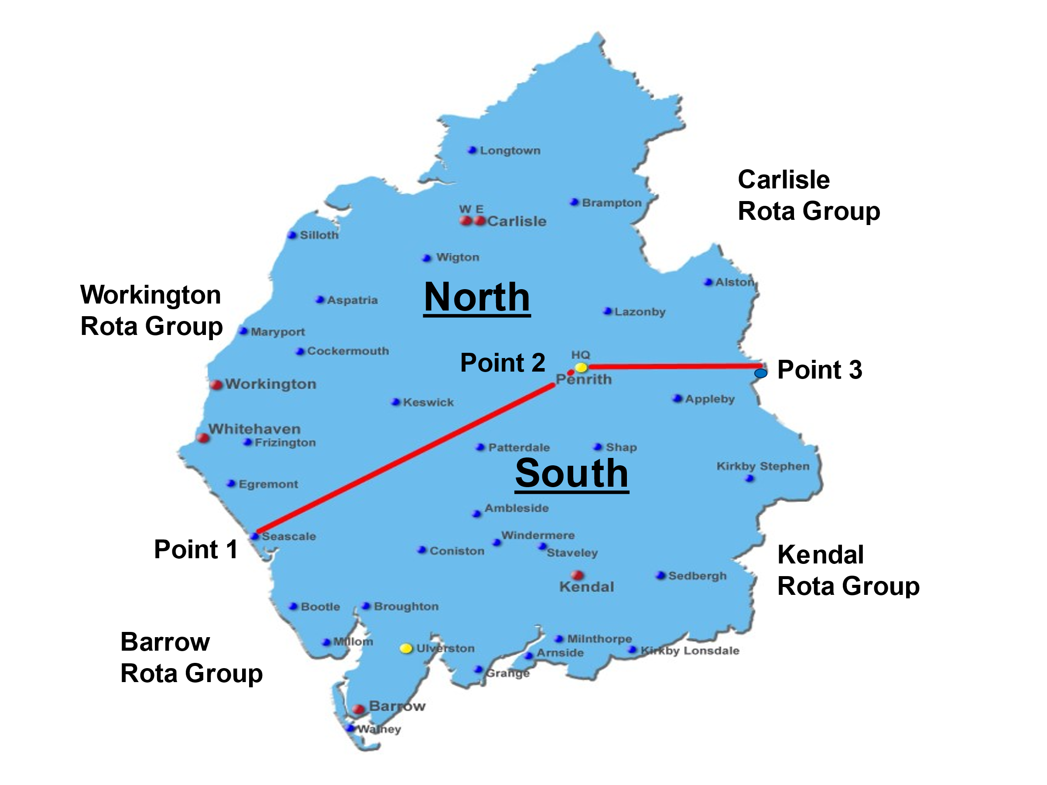

The following bullet points identify the North / South cover areas via a direct line between:

Point 1 on the map:
- Seascale NY 04021 01128
  - What3Words - jabs.harmonica.opens
Point 2 on the map:
- Penrith NY 52276 29057
  - What3Words - organ.unsecured.delivers
Point 3 on the map:
- Cow Green Reservoir NY 79854 29782
  - What3Words - correct.split.songbook

